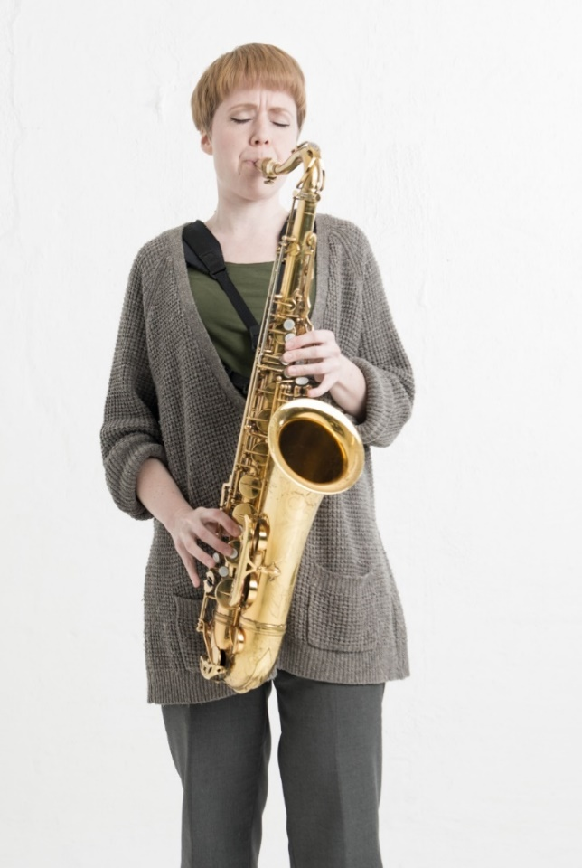
Gammalthea Presents
IDKA JAZZ
The Onion’s Core
With her album The Onion's Core, the Malmö-based saxophonist Ida Karlsson has done some soul-searching, finding inspiration from her background and childhood in Haraker, Sweden.

In a stressful time when every individual is the smith of her own fortune and artists are expected to be versatile in all arenas, Ida's song composing reveals a dismissal of excess and a return to her familial roots.

Ida's composing has resulted in eight rather distinctive jazz pieces. In one piece, traces of gospel hymns can be found; another harks back to traditional Swedish folk; while still other pieces maintain a more subtle complexity. "Baking" is a blues piece inspired by Swedish folk music and Jimmy Giuffre. "Popish" is a five-stroke play off of pop music and jazz harmonies.

THE ALBUM IS RELEASED THE 27TH OF APRIL!

The quartet IDKA JAZZ was started in Malmö, Sweden in the spring of 2017 and consists of Martin Juteus (piano), Pontus Häggblom (drums), Zacharias Holmkvist (contrabass) and Ida Karlsson (saxophone and clarinet).

The band presents its pieces with tangible presence, humor and a swinging Nordic sound. The musicians lift one another's ideas, their tones bearing witness to faith in solidarity and fellowship.
The record is recorded at The Village Recording Studio in Copenhagen, and since half the band comes from Finland, IDKA JAZZ indirectly becomes a Nordic collaboration aimed at building musical bridges.
The RELEASE CONCERT IS HELD ON MAY 16TH AT BULLRET/INKONST IN MALMÖ
"Swedish saxophone player Ida Karlsson shouldn't be praised simply because she is a woman, but because her explosive jazz solo in the piece "Wasp" lights a talented, well-needed fire into the universe!" Berlingske, Copenhagen
"Ida Karlsson is an explorer into the saxophones innermost nooks and crannies" Ystad Allehanda

